**Abhiram Basa**

**Python Assessment - 4 - 15/12/23**

Topics covered:

* Data Structure - Set ()
* Set methods
* Functions
* String Functions

**Set :**

Set is a data structure to store data in a structured manner.

Set is represented using curly braces {}.

Set is

* Un Ordered
* Does not allow duplicates
* Immutable

Defining set :

Syntax :

A = {“hexaware”}

It is a set.

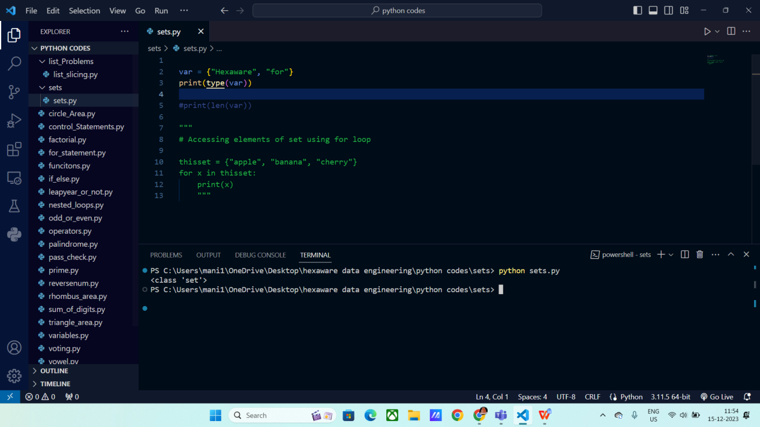

**Accessing set using for loop :**

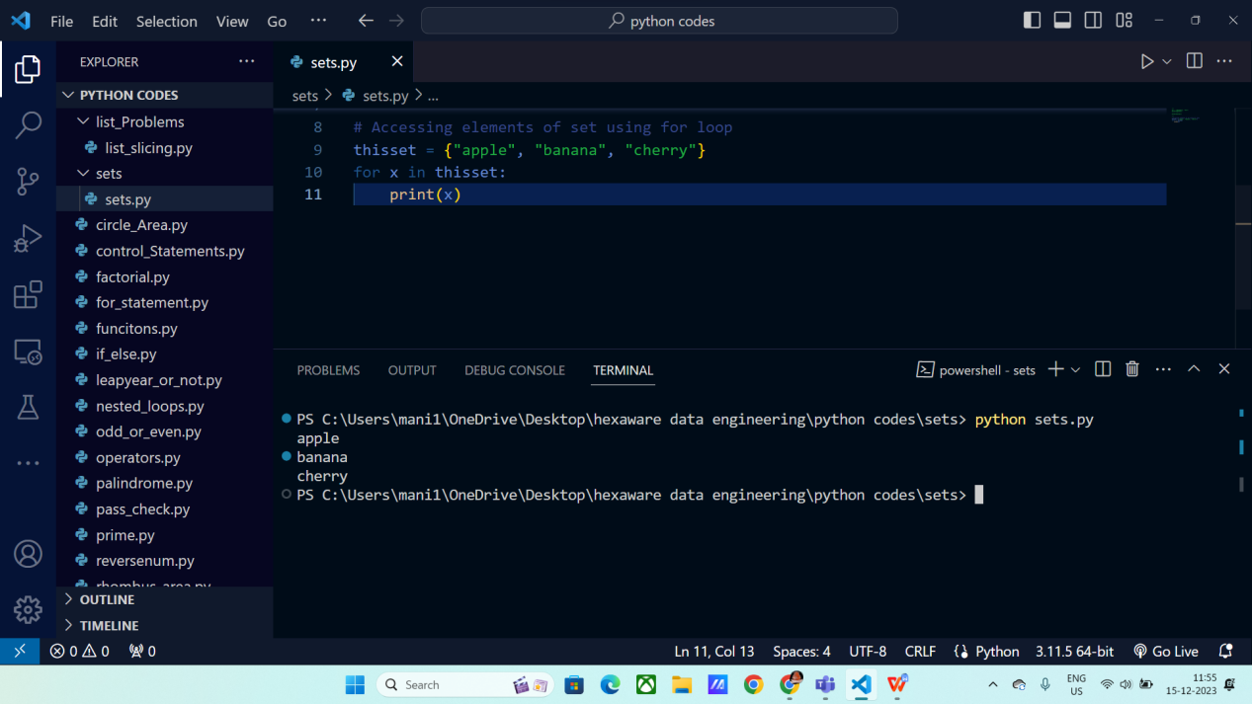

**Type casting a list into set:**

You can use the set() method to convert any data type to set.

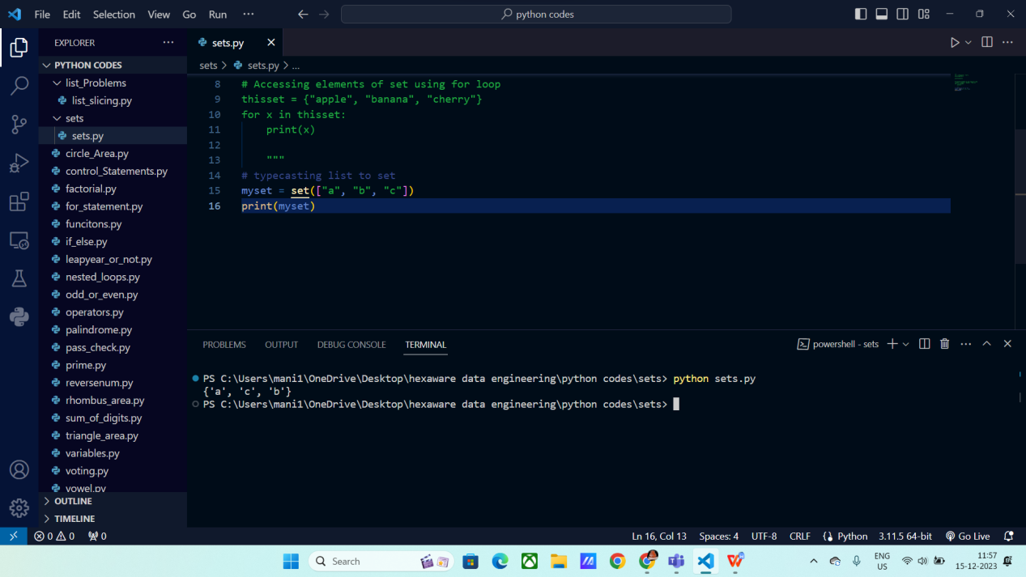

**Set Methods:**

**ADD :**

This method is used to add items to set.

Syntax:

Myset.add(“item_name”)

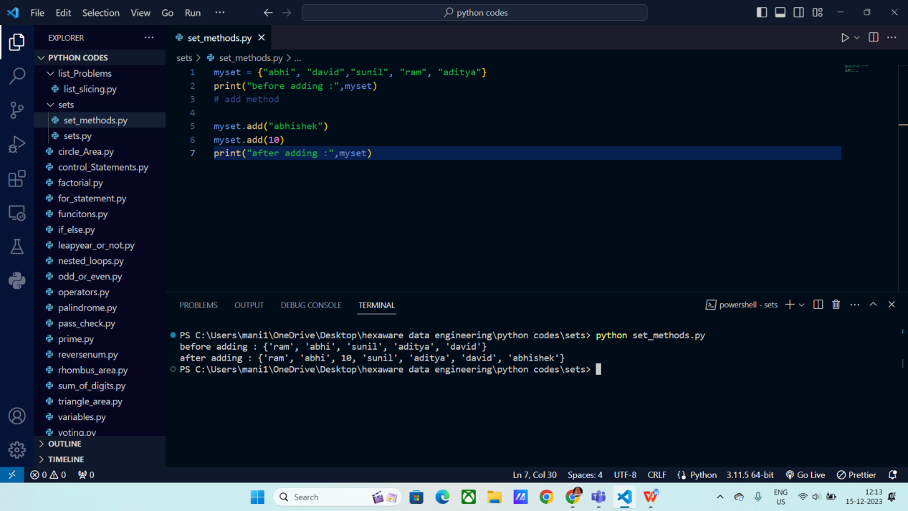

**Remove :**

This method is used to remove any particular item from the set.

Syntax:

Mylist.remove(“ item_name “)

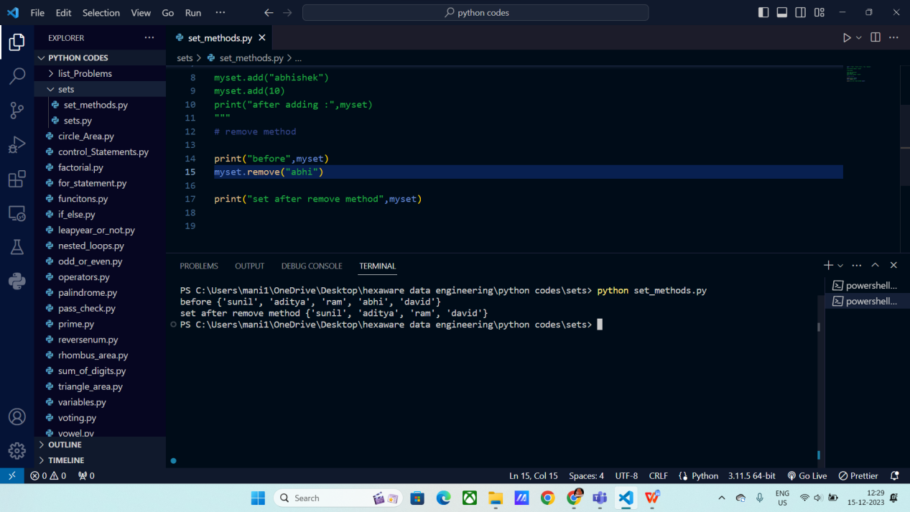

**Discard:**

It works same as remove method.

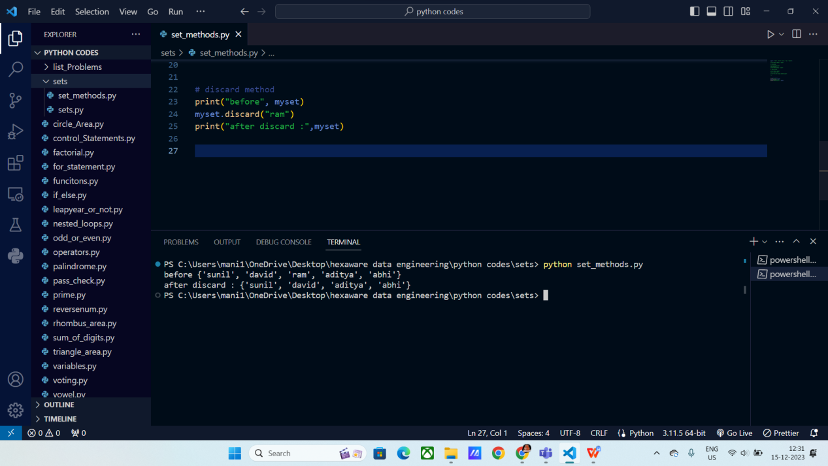

**Pop() :**

This method is used to remove item from last.

Syntax:

Myset.pop()

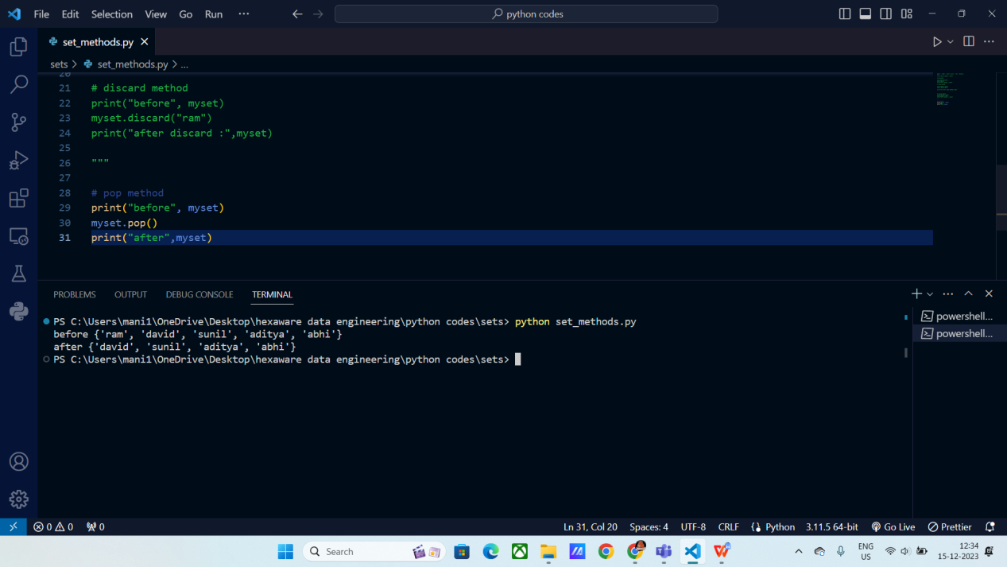

**Clear() :**

It empties the entire set.

Syntax:

Myset.clear()

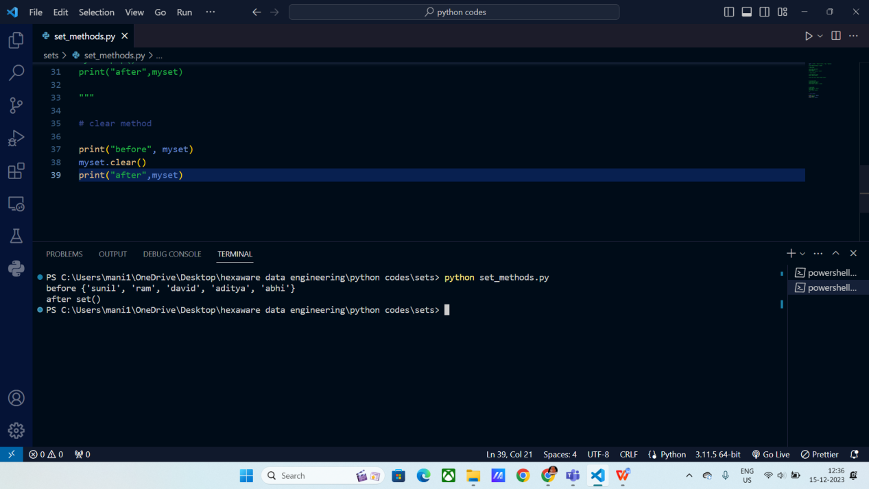

**Del :**

This method will completely deletes the set.

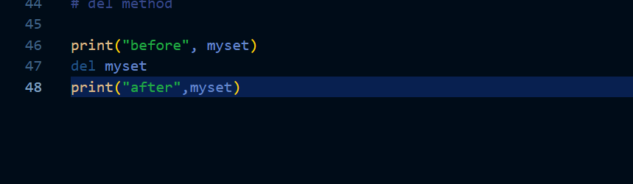

**Union() :**

It will give all the results from both the sets.

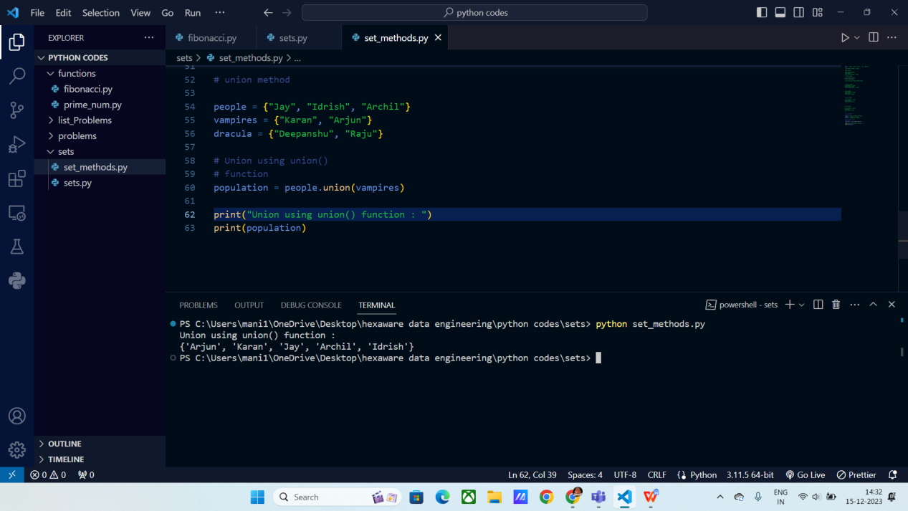

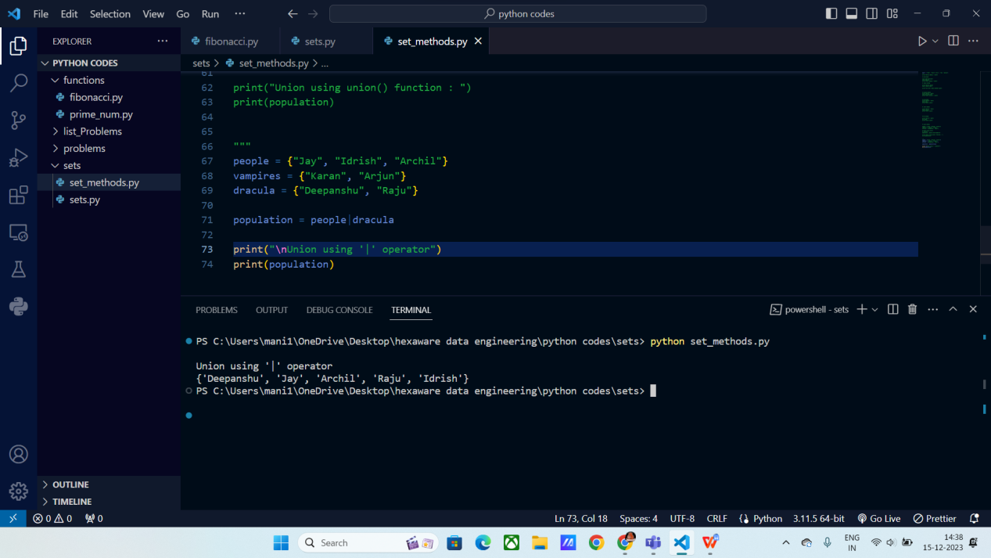

**Intersection:**

It will give the matching results from both the sets.

Syntax:

set3 = Set1.intersection.set2

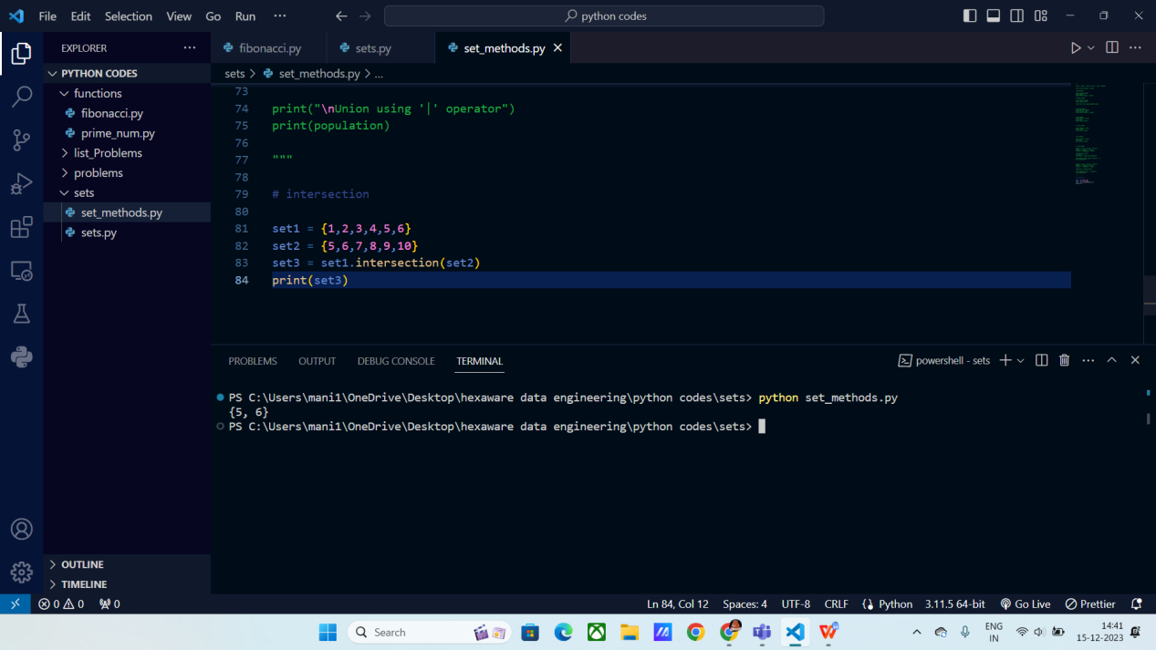

**Difference :**

It will give the items which are not in set 2 but present in set1.

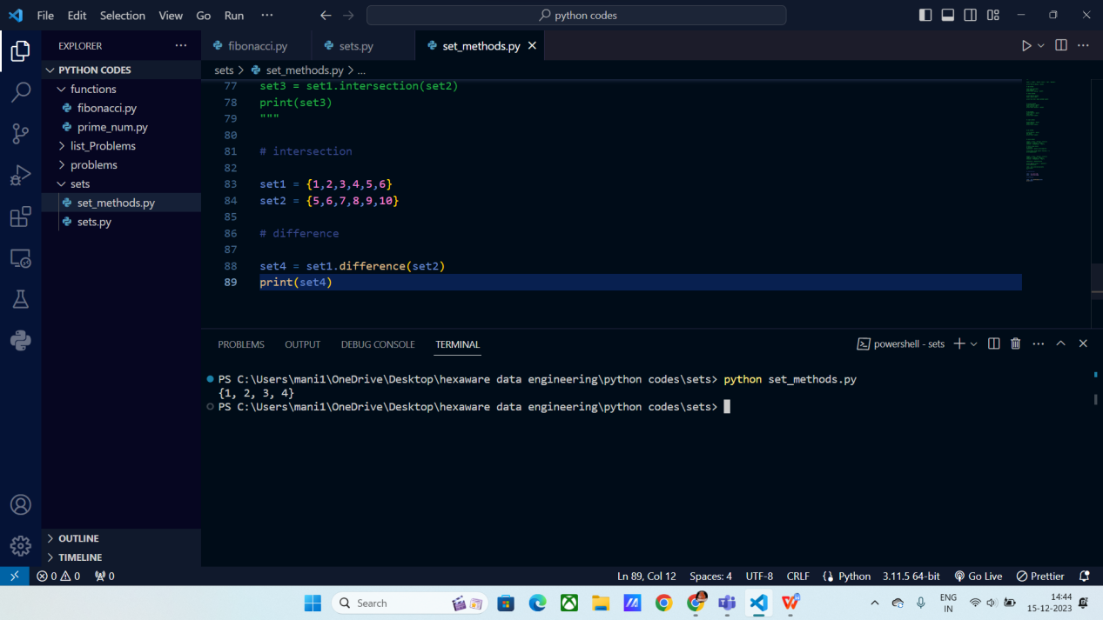

**Update():**

It updates the current set with updated set.

Syntax:

Set1.update(set2)

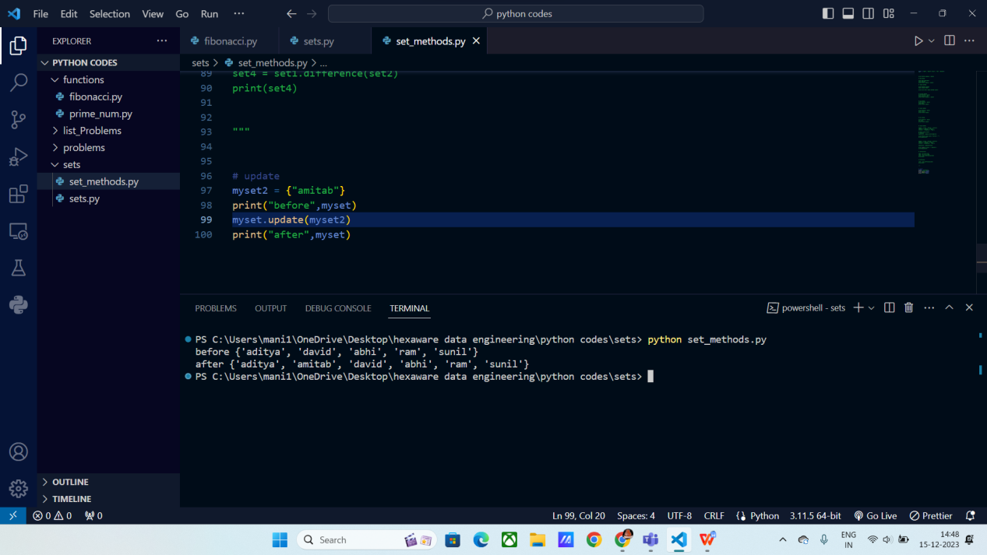

**Functions:**

Functions are used to run a block of code repeatedly.

It used in code re usability, where the same block of code can be used anywhere.

“ Def ” keyword is used to define a function in python.

Syntax :

Def function_name ( arguments ) :

# block of code

return statement

Function_Call(arguments)

When you define a function, you need to call the function in order to work.

Arguments:

Arguments are passed to functions. These are categorized into following

* Default argument
* Keyword arguments (named arguments)
* Positional arguments
* Arbitrary arguments.

Even or odd using Functions:

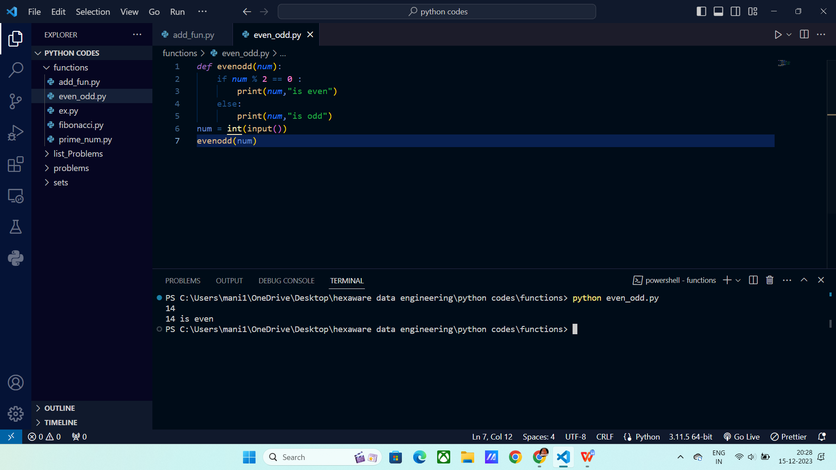

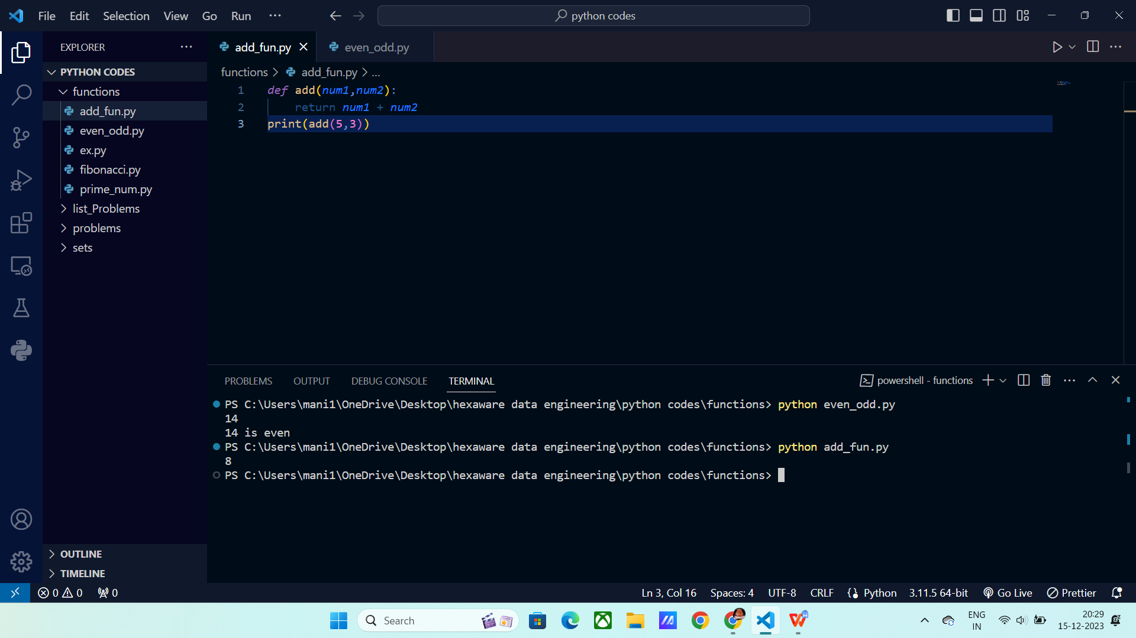

**\*\* kwargs:**

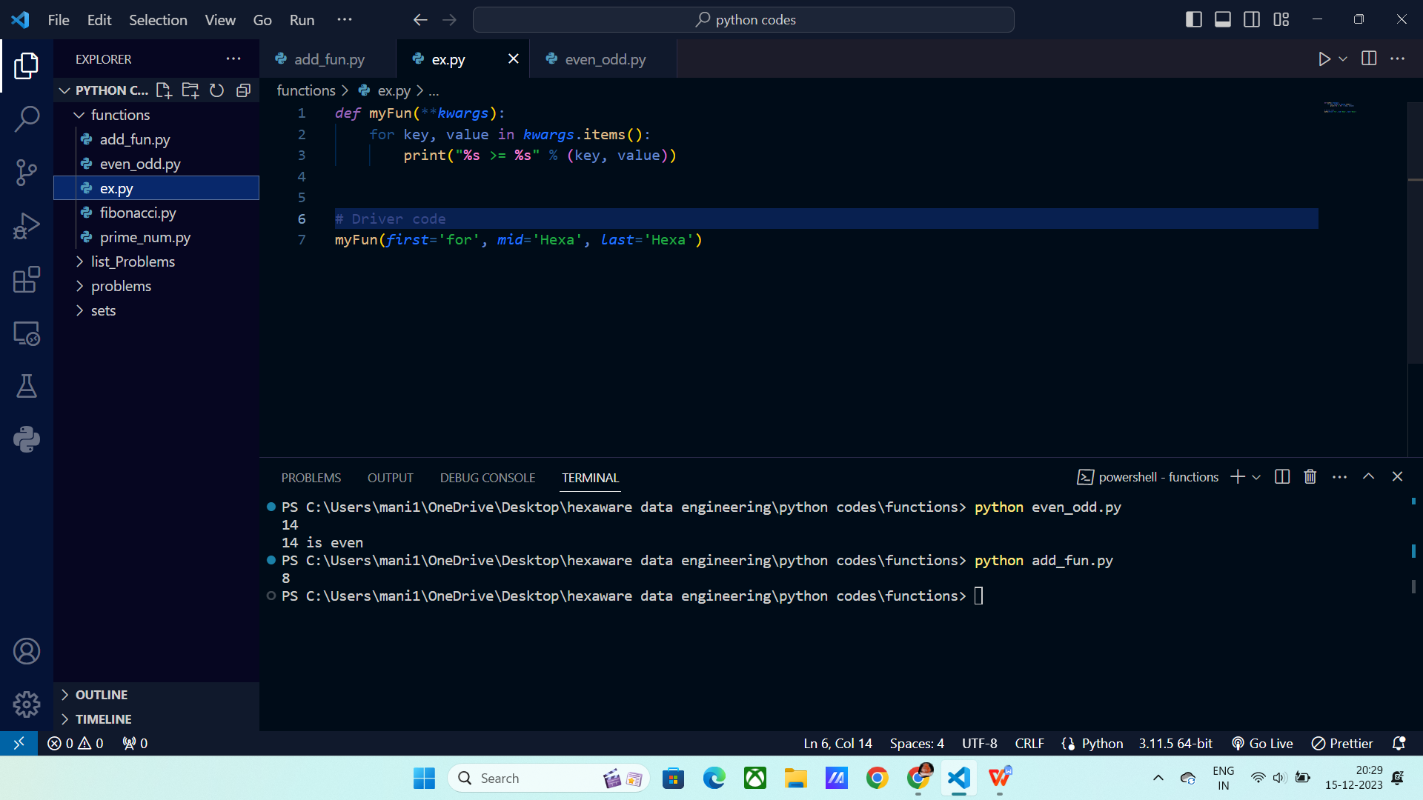

Program for Prime or Not :

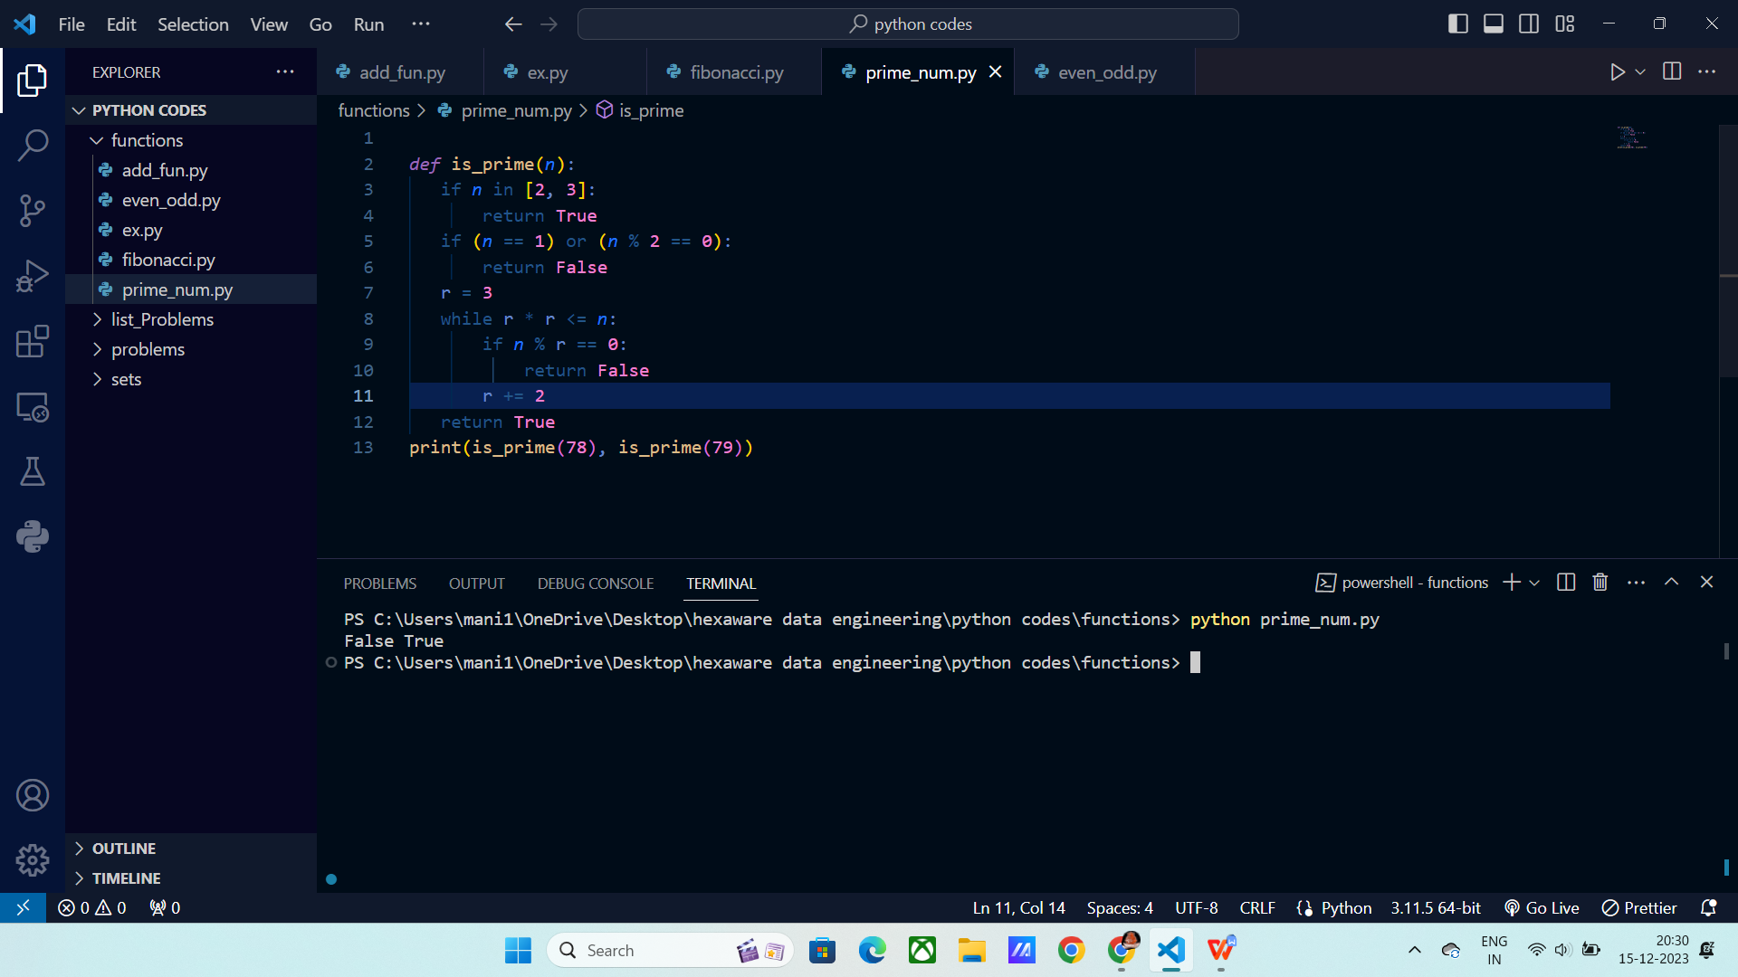

**Program for Fibonacci series :**

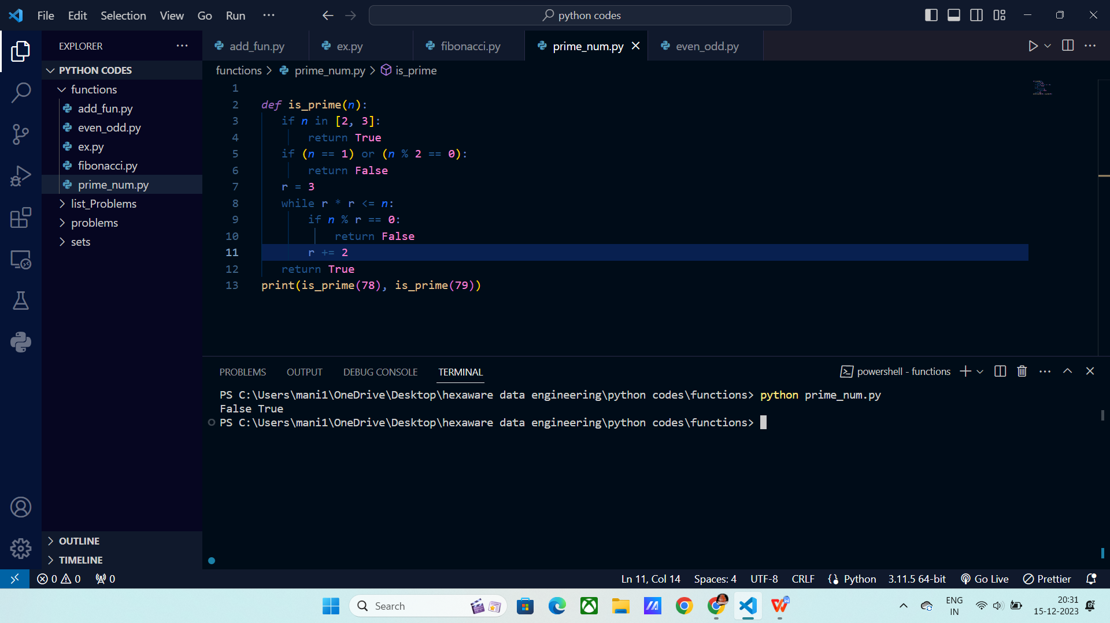

**String Functions:**

**Capitalize ():** It capitalize the starting letter of the sentence or word.

Syntax:

S1.capitalize()

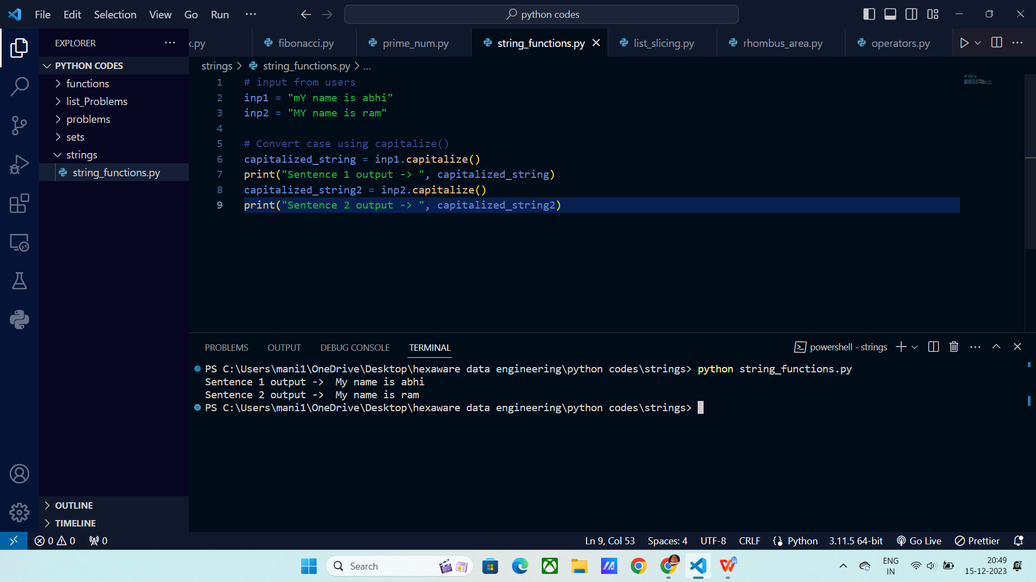

**Lower () :** It converts the input into lower case letters.

Syntax:

S1.lower()

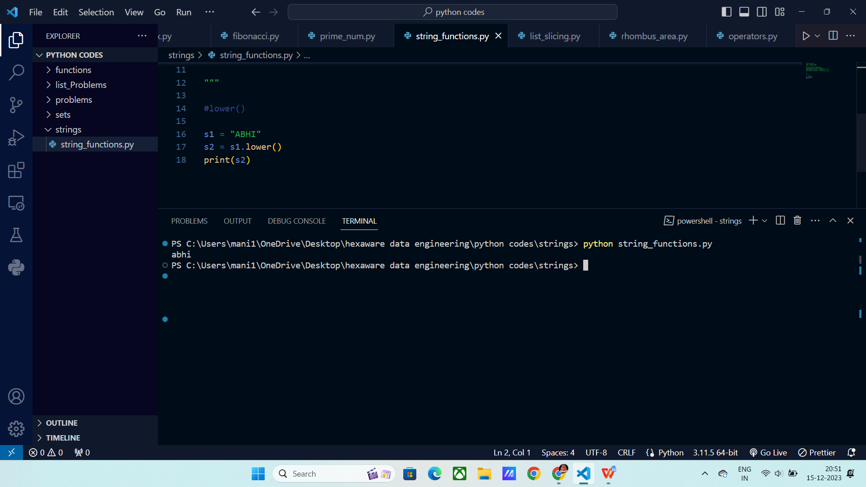

**Upper() :** It converts the input into upper case letters.

Syntax:

S1.upper()

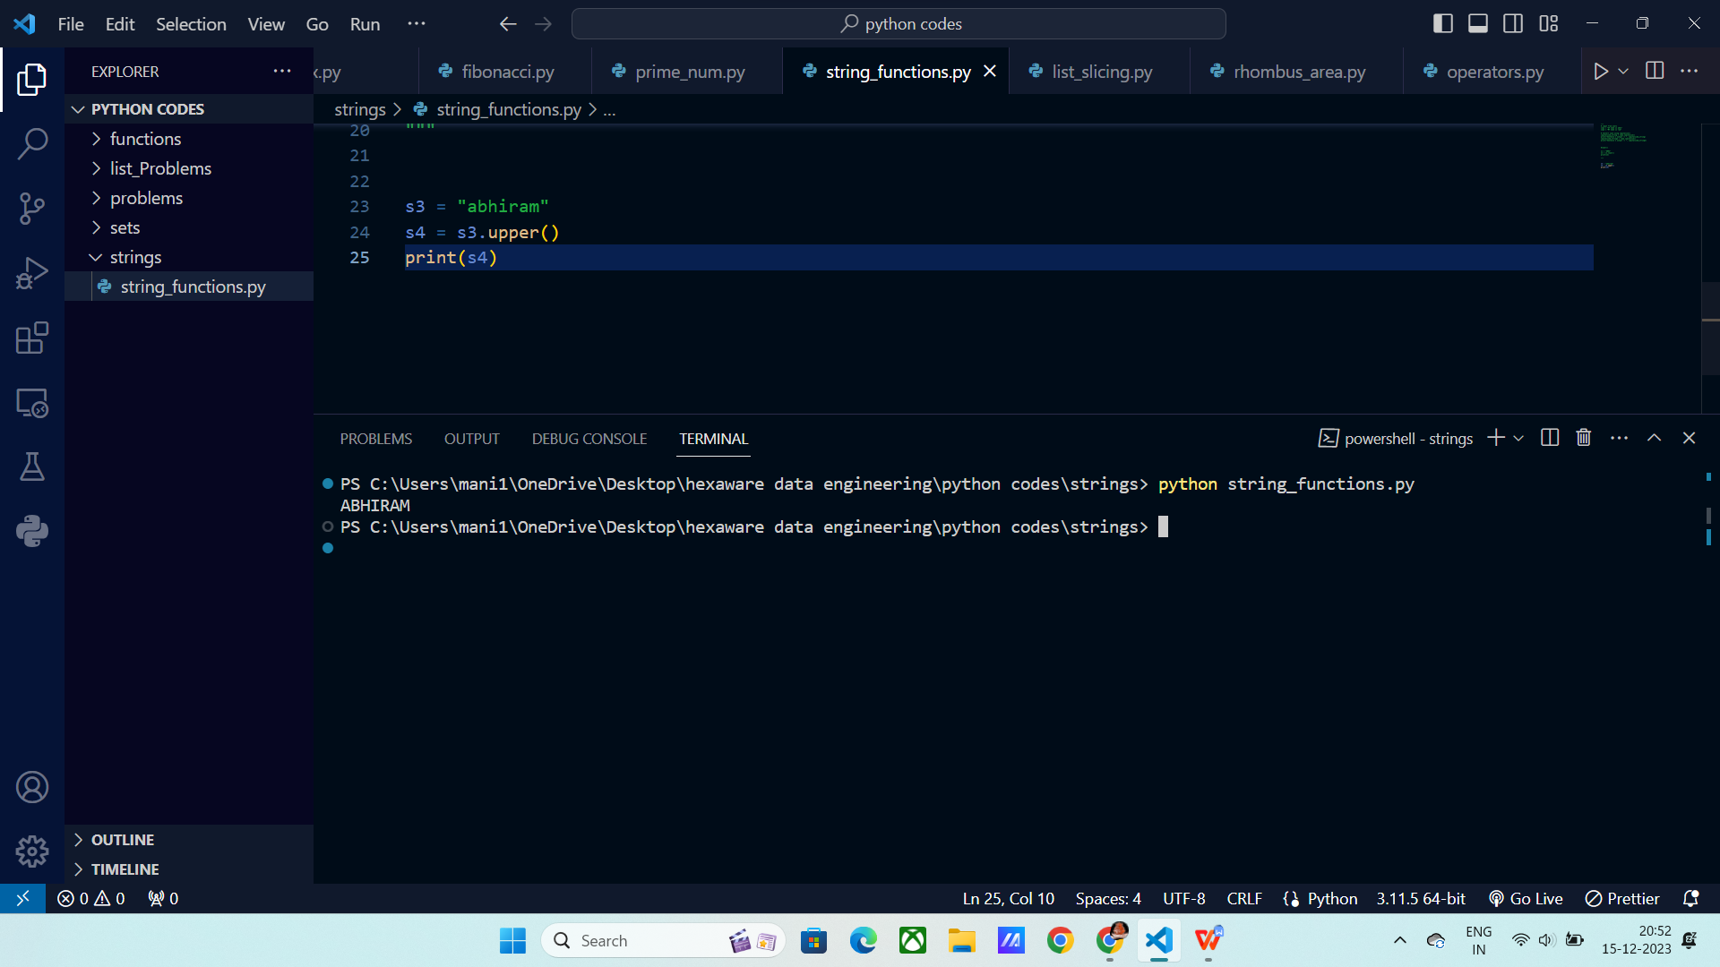

**Isalpha():** It checks whether the given input contains alphabets or not.

Syntax:

S1.isalpha() == True

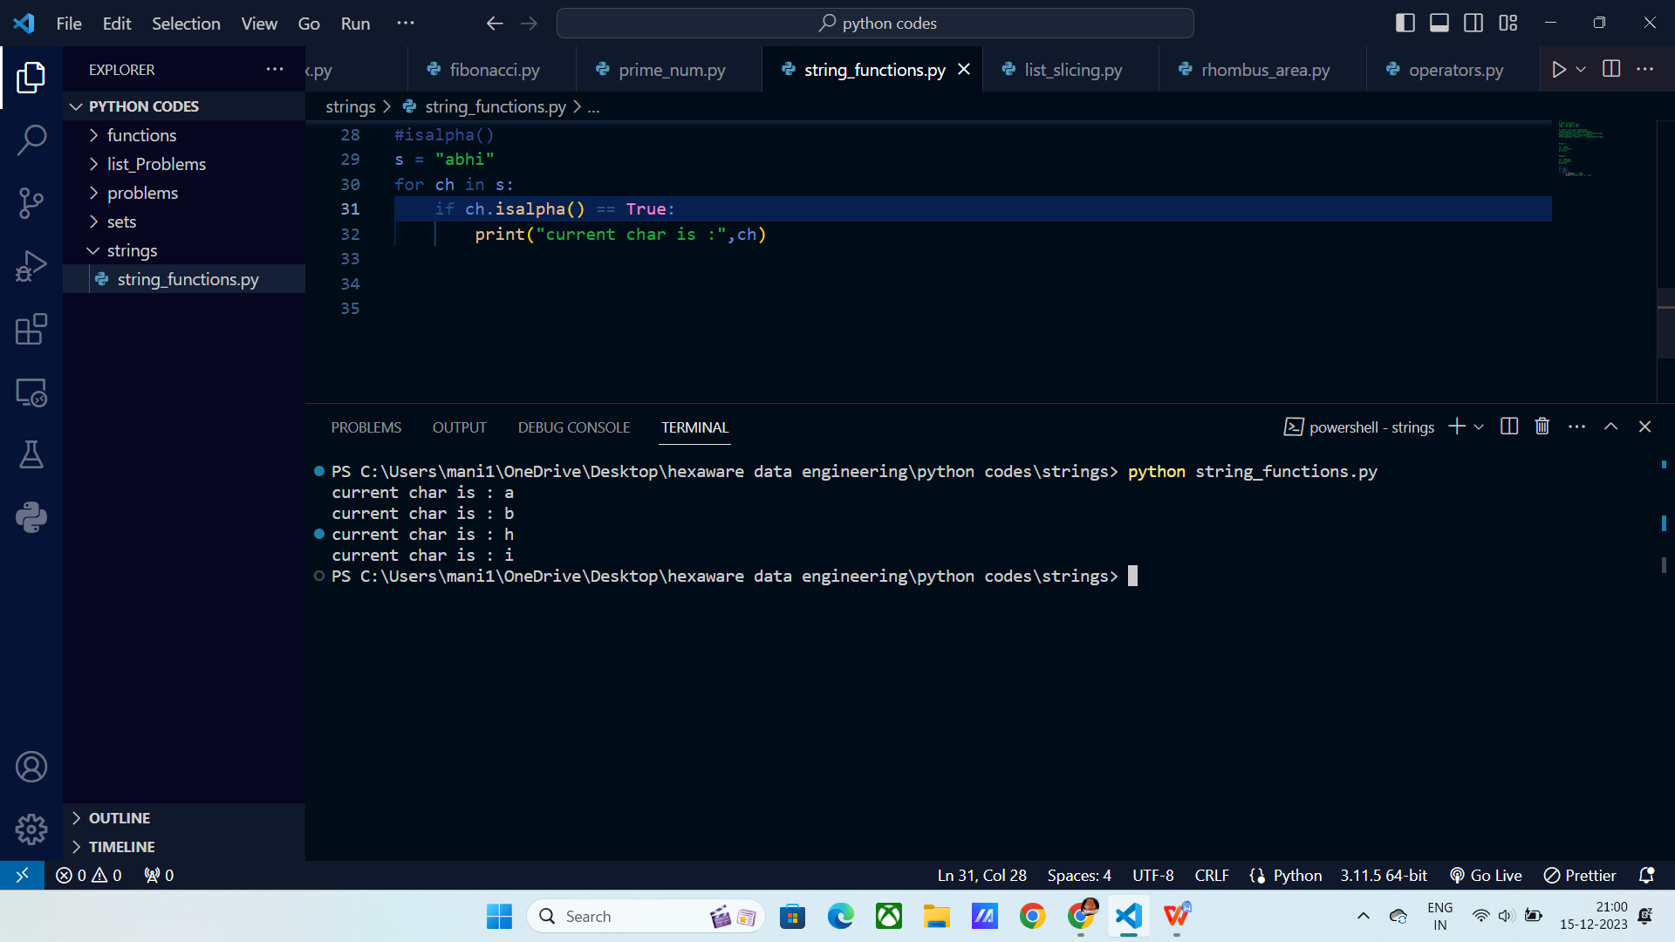

**Isalnum():** It checks whether the input contains both characters and numbers.

Syntax:

S1.alnum()

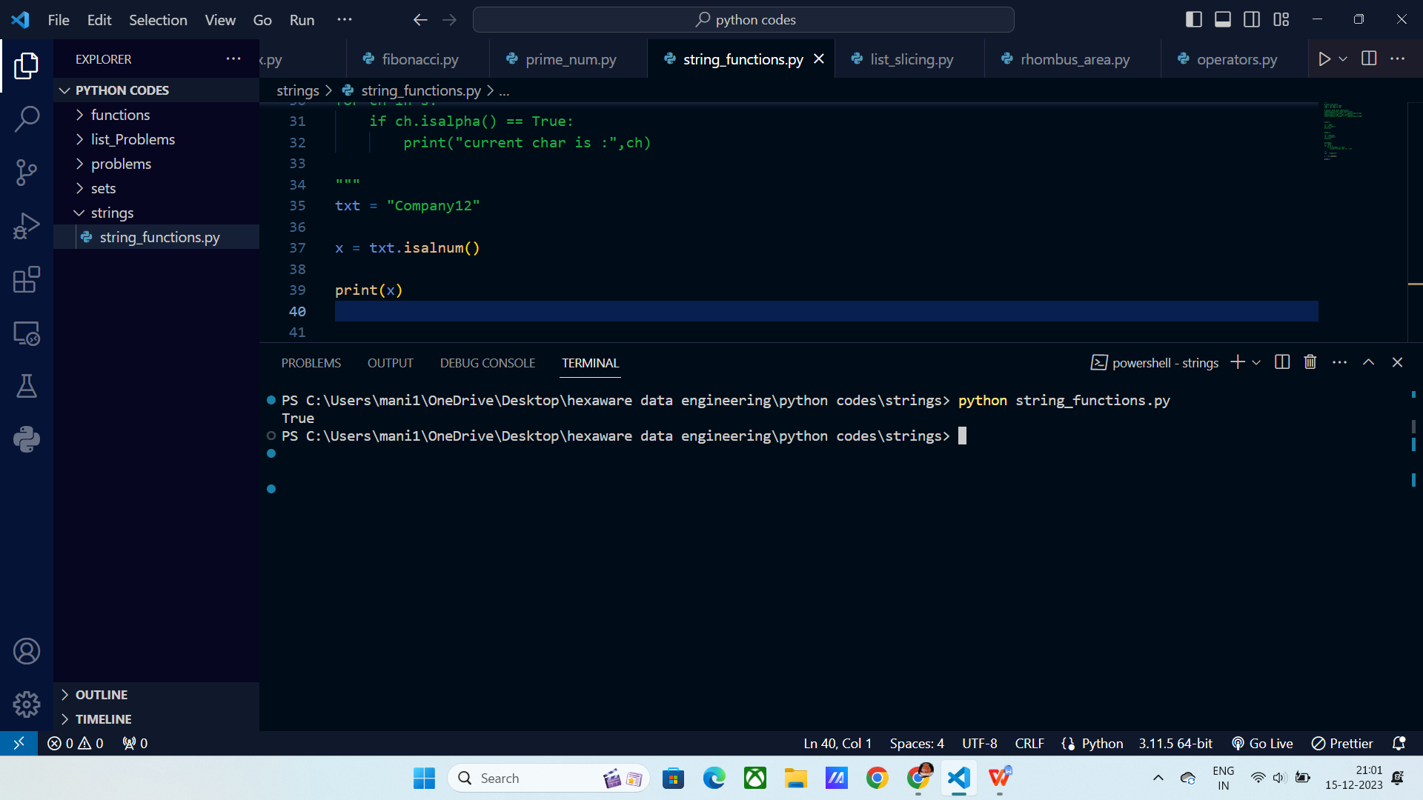

**Count():** It counts the specifies item occurrences.

Syntax:

Count(“input”)

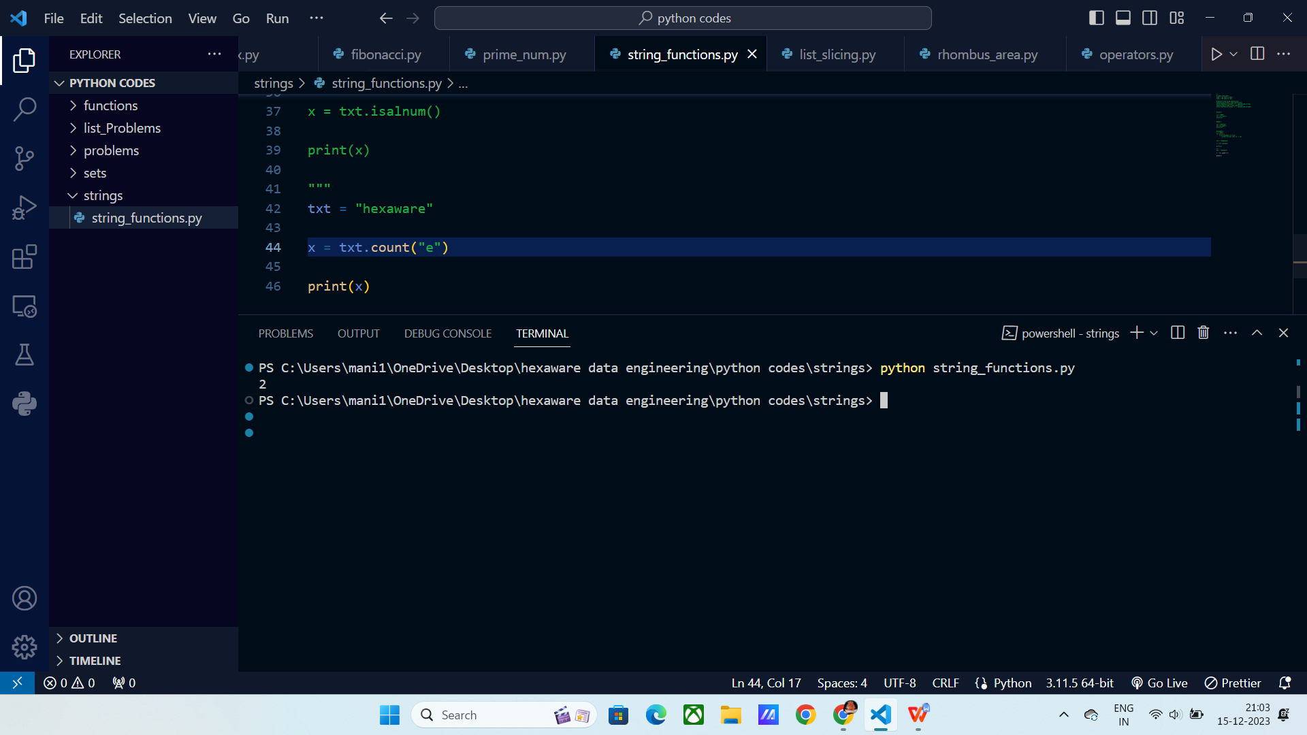

**Find():** It finds the first occurance of the input and returns the index.

Syntax:

Find(“input”)

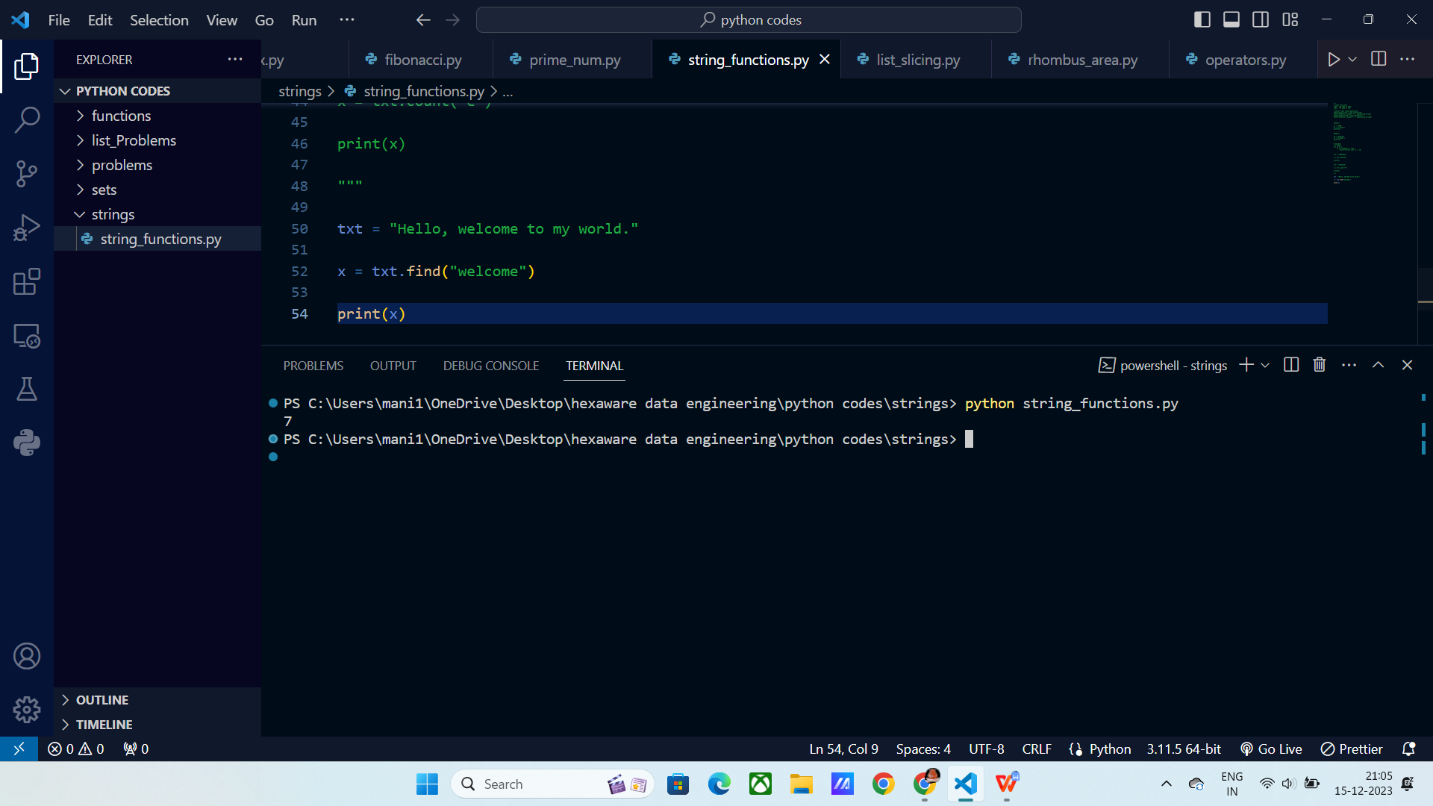

Replace(): It replaces the mentioned value with given value.

Replace(“string”,” replaced string ”)

